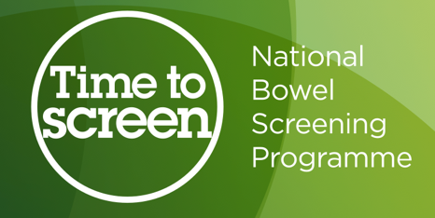
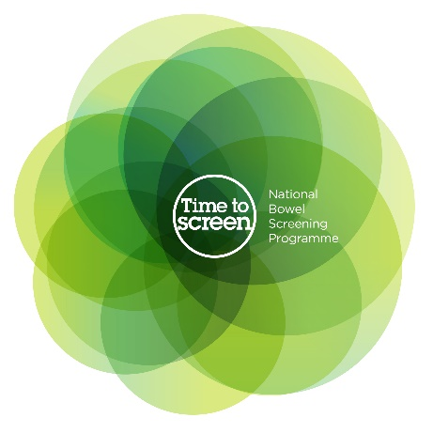

All about bowel screening
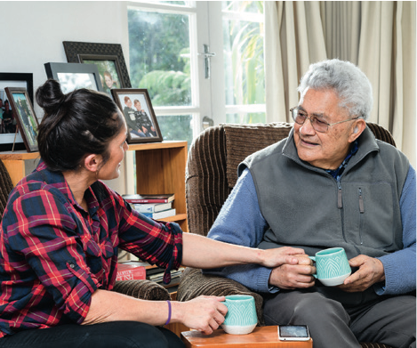

Factsheet 1 –

What is bowel cancer?

Before you read this document

Some of the information in this document may make people upset when they are reading it.

This information is:

- not meant to scare anyone.

If you are worried after reading this document you can talk about it with your:

- family / friends
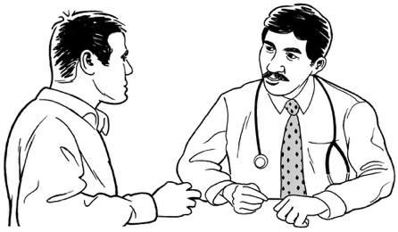
- doctor.

What you will find in here

Page number:
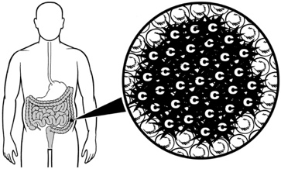

What is bowel cancer? 4

What are the symptoms of
bowel cancer? 7
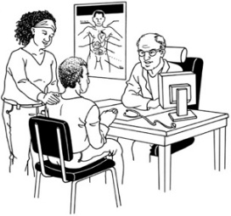

How common is bowel cancer? 8

Who is most at risk of bowel
cancer? 9

What is the National Bowel Screening Programme? 12

Page number:
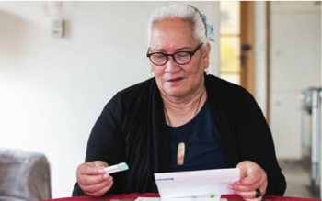

Why is having bowel screening important? 15
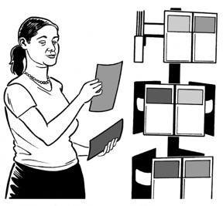

Where to find more information 16

What is bowel cancer?

This Easy Read document is about screening for bowel cancer.

Your bowel:

- is a part of your body that helps you digest the food you eat
- joins your stomach to your bottom also called your anus

- helps your poo leave your body
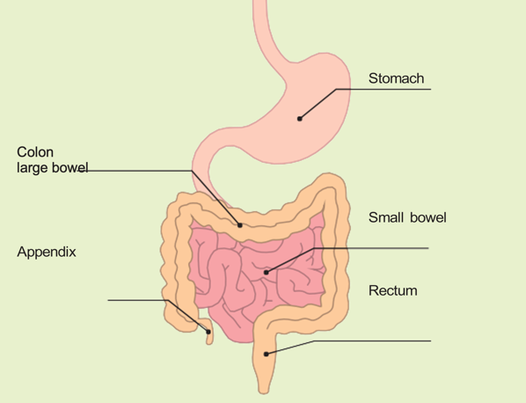
- is made up of the:

- small bowel

- large bowel called your colon

- rectum.
Digest means that your body breaks down the food you eat to turn it into energy for your body.
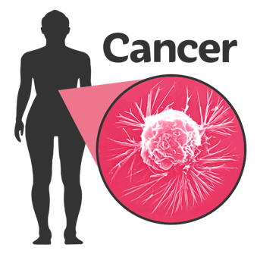

Cancer is a disease that can make people very sick.

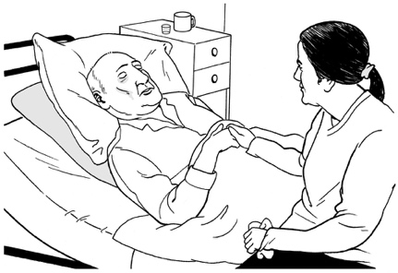
Sometimes cancer can make people so sick that they die.

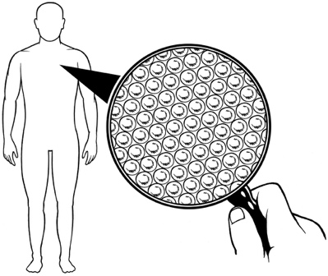
Your body is made up of lots of tiny pieces called cells.

Sometimes these cells can go wrong.
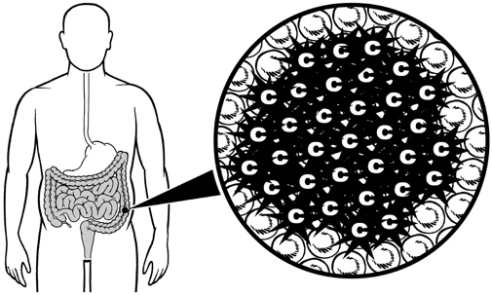

Bowel cancer starts when cells in the bowel begin to grow out of control.

If 1 cell in your body goes wrong it can make other cells go wrong.

The cells can turn into a lump called a polyp.

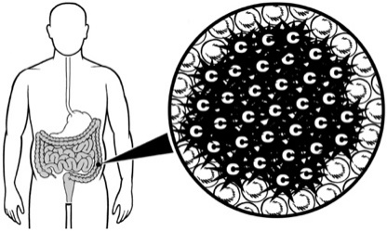
It is possible that some polyps may turn into bowel cancer.

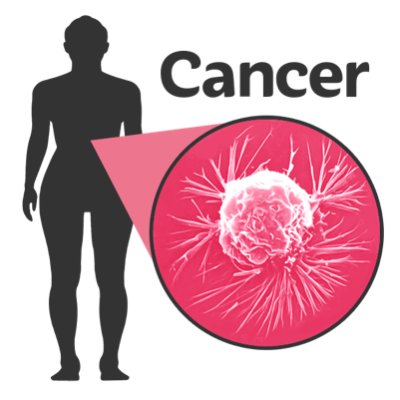
It can take a long time before the cancer:

- grows

- spreads to other parts of the body.

What are the symptoms of bowel cancer?

Symptoms are things that happen when you are sick that change how you feel / how your body works.

Common symptoms of bowel cancer are things like:

- a change in how you usually poo that goes on for many weeks
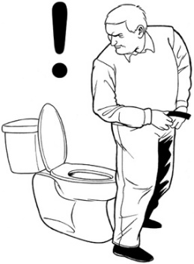
- seeing blood in your poo.

These symptoms are most often caused by other things.

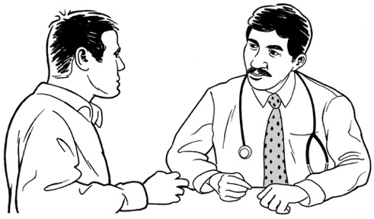
If you have these symptoms you should still see your doctor to make sure it is not bowel cancer.

How common is bowel cancer?

Bowel cancer is sadly very common in New Zealand.

Every year in New Zealand:
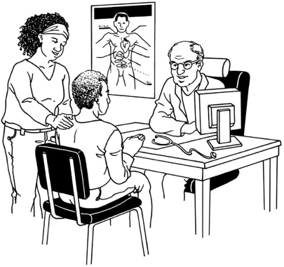
- more than 3 thousand three hundred people find out they have bowel cancer

- more than 1 thousand 2 hundred people die from bowel cancer.

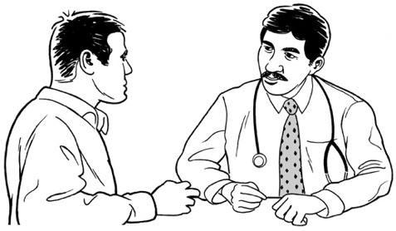
It is important to make sure you go to your doctor straight away if you think you have any signs / symptoms of bowel cancer.

Who is most at risk of bowel cancer?

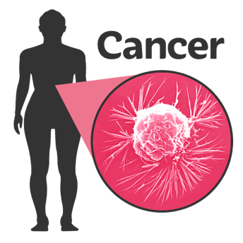
Some people are more likely than others to get bowel cancer.

This is called being at risk.

People who are over 60 years old are more at risk of bowel cancer.

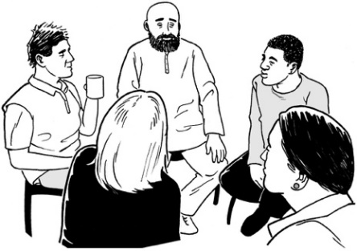
Men seem to get bowel cancer more than woman.

You can make it less likely that you get bowel cancer by looking after yourself by:

- making sure you exercise often

- not smoking

- eating healthy food like:

- fruit

- vegetables

- foods that have a lot of fibre in them such as wholegrain bread.

Some people may be more at risk of bowel cancer even if they look after themselves well.

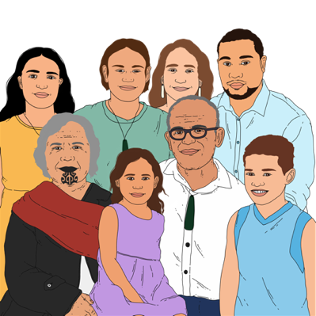
Things that can make you more at risk of bowel cancer are:

- you have 2 or more close family members on the same side of the family who have had bowel cancer
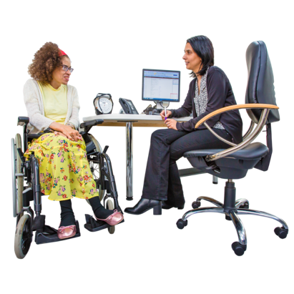
- you have a close family member who was diagnosed with bowel cancer at a young age / under 55 years old
- you and your family have a known / suspected genetic bowel cancer syndrome
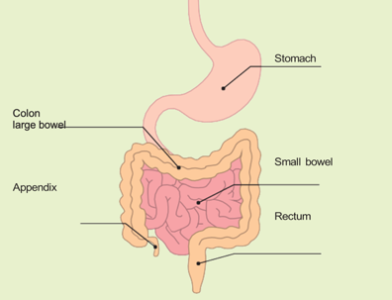
- you have had a disease of the bowel like ulcerative colitis for more than 10 years.

What is the

National Bowel Screening Programme?

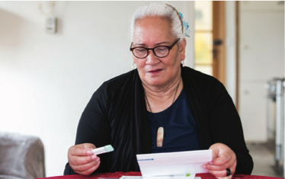
Screening is a kind of test that looks for very early signs of cancer.

You can have screenings even if you feel well.

Regular bowel screening is:
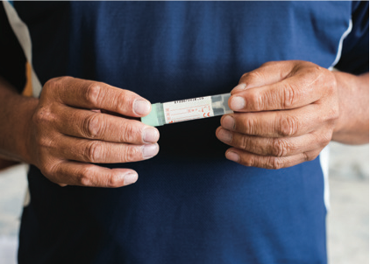
- offered to people who do not
have symptoms of bowel cancer

- can help find out early if you have bowel cancer.

The National Bowel Screening Programme is a programme in New Zealand that can test for bowel cancer.

It does not cost you any money to have the screening / test.

The screening is offered to everyone aged 60 to 74 who gets publicly funded health care.

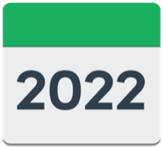
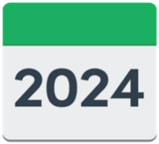
The screening is offered every 2 years.

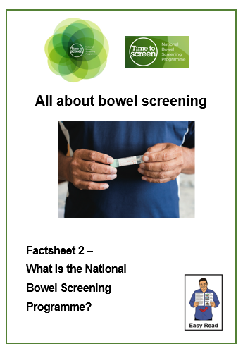
You can find more information about the bowel screening programme in 2 Easy Read documents called:

- Factsheet 2 – What is the National Bowel Screening Programme?
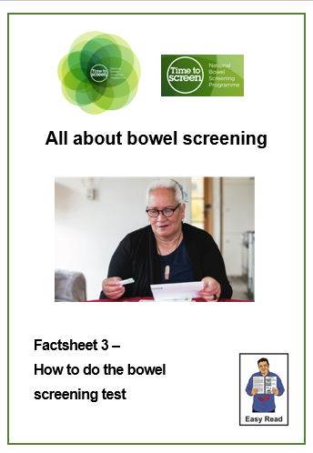
- Factsheet 3: How to do the bowel screening test.

You can find both of these factsheets on the National Bowel Screening Programme website:

www.timetobowelscreen.nz

Why is bowel screening important?

It is possible to have bowel cancer
and not have any warning signs / symptoms.

Having a bowel screening every 2 years could help save lives.

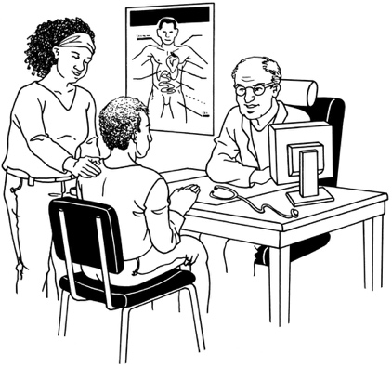
It is very important to talk to your doctor if you notice you have any symptoms of bowel cancer at any time.

Where to find more information

You can find out more information about the National Bowel Screening Programme on their website at:

www.timetobowelscreen.nz

You can contact the National Bowel Screening Programme:

- by phone on:

0800 924 432

- by email at:
info@bowelscreening.health.nz

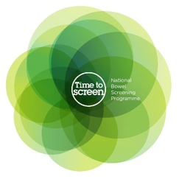
This information has been written by the National Bowel Screening Programme.

It has been translated into Easy Read by the Make it Easy Kia Māmā Mai service of People First New Zealand Ngā Tāngata Tuatahi.
The ideas in this document are not the ideas of People First New Zealand Ngā Tāngata Tuatahi.
Make it Easy uses images from:

- Changepeople.org

- Photosymbols.com

- SGC Image Works

- Huriana Kopeke-Te Aho.

Some images have been provided by National Bowel Screening Programme.
All images used in this Easy Read document are subject to copyright rules and cannot be used without permission.

