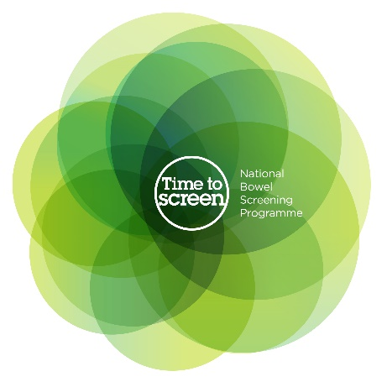
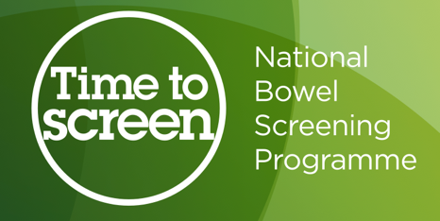

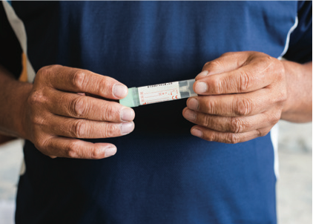
All about bowel screening

Factsheet 2 –

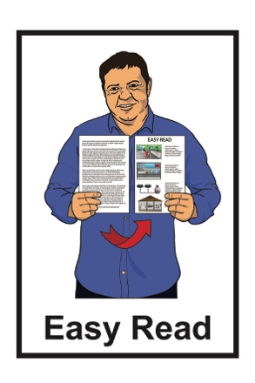
What is the National

Bowel Screening

Programme?

Before you read this document

Some of the information in this document may make people upset when they are reading it.

This information is:

- not meant to scare anyone.

If you are worried after reading this document you can talk about it with your:

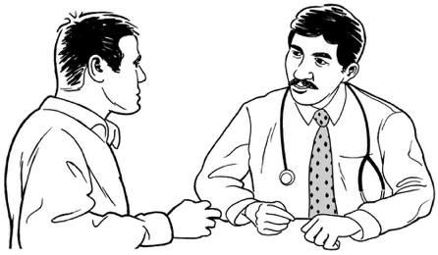
- family / friends

- doctor.

What you will find in here

Page number:

What is the National Bowel Screening Programme? 3
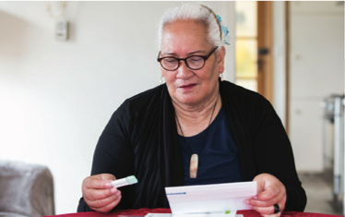

What is the screening test? 7

Who should do the screening
test? 8

Who should not do the
screening test? 10
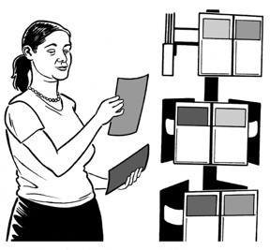

Where to find more information 13

What is the

National Bowel Screening Programme?

This Easy Read document is about screening for bowel cancer.

Screening is a kind of test that looks for very early signs of cancer.

You can have screenings even if you feel well.

The National Bowel Screening Programme is a programme in New Zealand that can test for bowel cancer.

It does not cost you any money to have the screening test.

The screening is offered to everyone aged 60 to 74 who gets publicly funded health care.
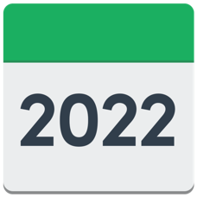

The screening is offered every 2 years.

The screening test is:

- done in your own home
- is easy to do.

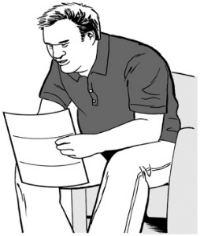
Everyone who is eligible for a bowel screening test will be sent:

- a letter asking them to take part in the screening

- a consent form for the screening

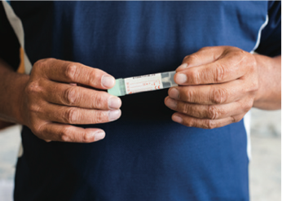
- a free bowel screening test kit with instructions about how to use it.

Eligible means someone meets certain rules that means they can have / do something.

Consent is when you say yes to something.

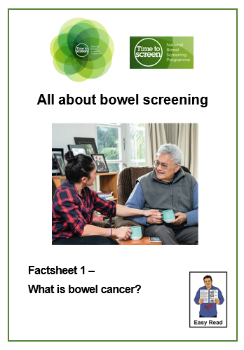
You can find more information about bowel cancer and bowel screening in 2 Easy Read documents called:

- Factsheet 1 – What is bowel cancer?
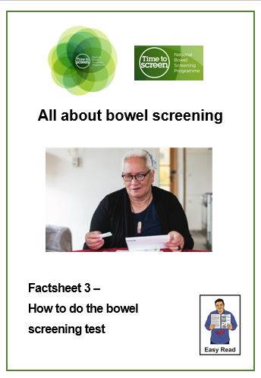
- Factsheet 3: How to do the bowel screening test.

You can find both of these factsheets on the National Bowel Screening Programme website:

www.timetobowelscreen.nz

What is the screening test?

The test used by the National Bowel Screening Programme is called a faecal immunochemical test also called a FIT.

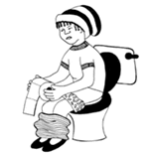
The test can tell if there are tiny amounts of blood in your poo.

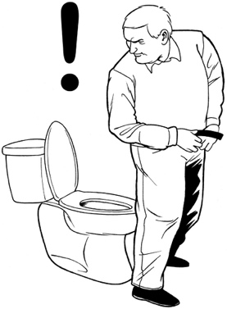
Having blood in your poo can be an early warning sign that something is wrong with your bowel.

You can find more information about how to do the screening test in the Easy Read document:

Factsheet 3 – How to do the bowel screening test.

Who should do the screening test?

The screening test is for people who:

- are 60 to 74 years of age
- do not have any signs /
symptoms of bowel cancer.

Symptoms are things that happen when you are sick that change how you feel / how your body works.

You can find out more about the symptoms of bowel cancer in the Easy Read document:

Factsheet 1 – What is bowel cancer?

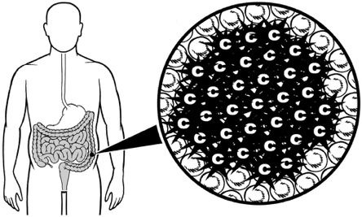
Some people have more risk of getting bowel cancer.

Things that can make you more at risk of bowel cancer are:

- you have 2 or more close family members on the same side of the family who have had bowel cancer
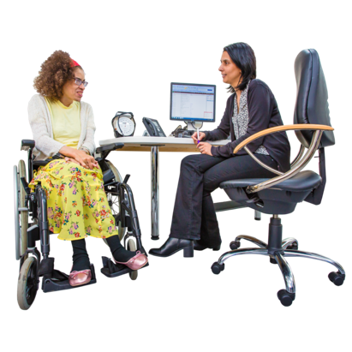
- you have a close family member who was diagnosed with bowel cancer at a young age / under 55 years old
- you and your family have a known / suspected genetic bowel cancer syndrome

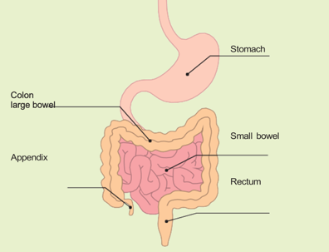
- you have had a disease of the bowel like ulcerative colitis for more than 10 years.

If you are at more risk, talk to your doctor.
If you are at more risk, you should still do the bowel screening test.

Who should not do the screening test?

The bowel screening test is not right for everyone.

You should talk to your doctor if you are not sure if bowel screening is right for you.

You should not be part of the bowel screening programme if you:

- have symptoms of bowel cancer

- are on a bowel polyp / bowel cancer surveillance programme

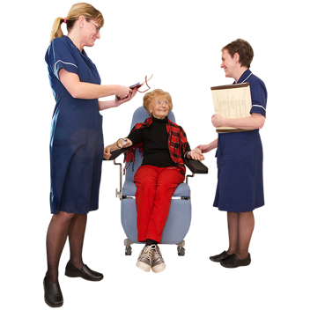
- are currently getting treatment for bowel cancer

- have had bowel cancer in the past.
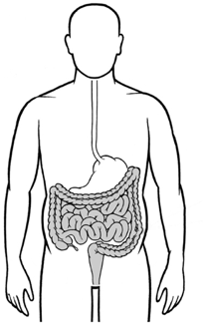
You should also not be part of the bowel screening programme if you:

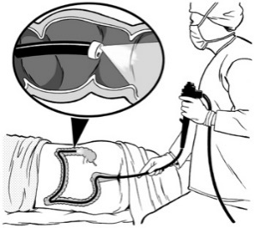
- have had your large bowel taken out by an operation.

- have had a colonoscopy in the last 5 years.
- are seeing your doctor about bowel problems

- have a disease of the bowel like:

- ulcerative colitis

- Crohn’s disease.

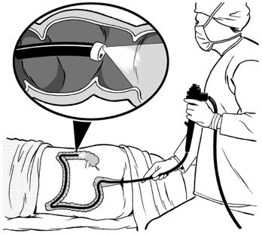
A colonoscopy is a medical test done in a hospital.

A tube with a very small camera on it is put into your bottom to check for any problems in your bowel.

You can find out more about colonoscopy on page 19 of the Easy Read document:

Factsheet 3 – How to do the bowel screening test.

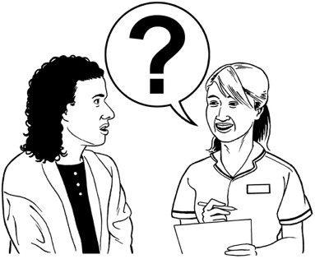
You should let the National Bowel Screening Programme know if:

- you have had a colonoscopy in the last 5 years

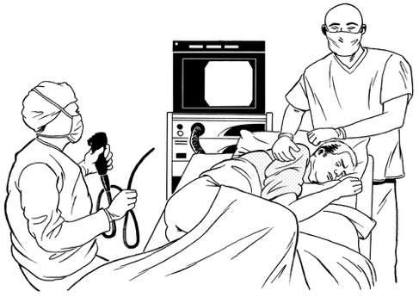
and

- you have been told you are not likely to have regular colonoscopies.

The National Bowel Screening Programme will invite you to join the
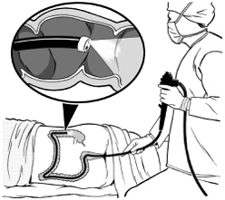
screening programme again 5 years from when you had your colonoscopy.

Where to find more information

You can find out more information about the National Bowel Screening Programme on our website at:

www.timetobowelscreen.nz

You can contact the National Bowel Screening Programme:

- by phone on:

0800 924 432
- by email at:
info@bowelscreening.health.nz

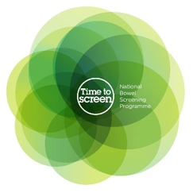
This information has been written by the National Bowel Screening Programme.

It has been translated into Easy Read by the Make it Easy Kia Māmā Mai service of People First New Zealand Ngā Tāngata Tuatahi.
The ideas in this document are not the ideas of People First New Zealand Ngā Tāngata Tuatahi.
Make it Easy uses images from:

- Changepeople.org

- Photosymbols.com

- SGC Image Works

- Huriana Kopeke-Te Aho.

Some images have been provided by National Bowel Screening Programme.
All images used in this Easy Read document are subject to copyright rules and cannot be used without permission.

